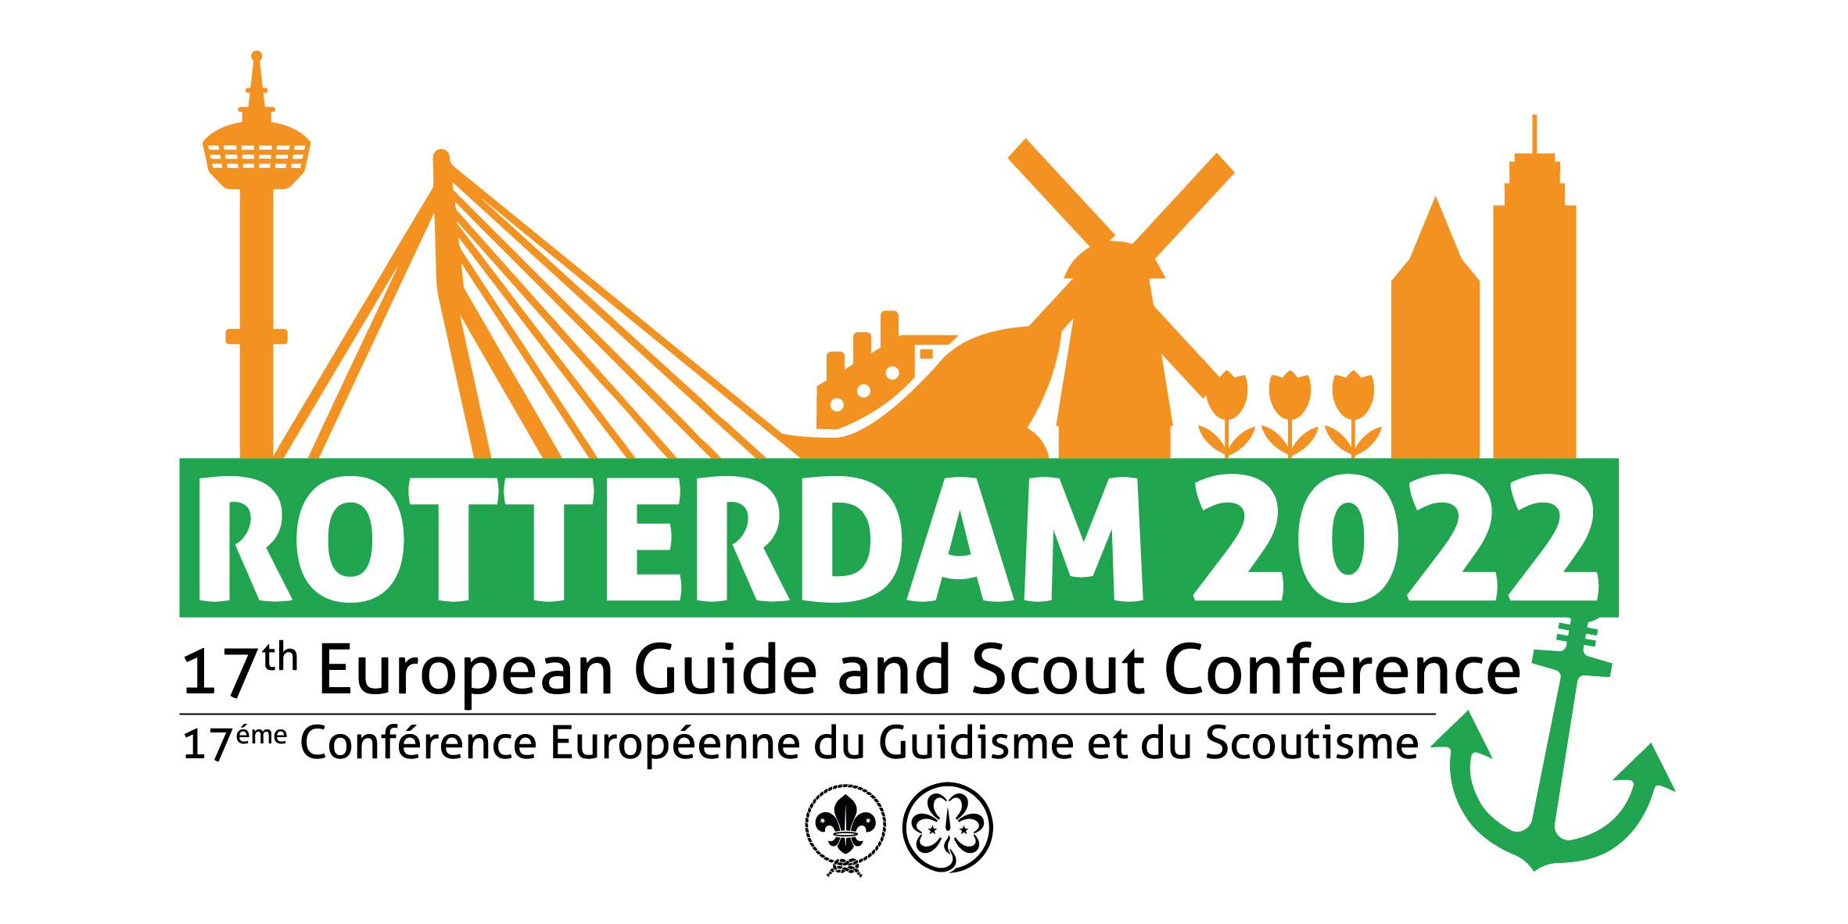
17th European Guide and Scout Conference
Rotterdam NL | 22-27 July 2022

Appointment of Heads of delegation, Delegates, and Observes.
Please select the event your delegation will attend:
17th European Guide Conference | 24th European Scout Conference

(Please TICK appropriate Conference and use BLOCK LETTERS)
Country of Member Organisation
National Scout Organisation (WOSM)
Member Organisation (WAGGGS)
- For each delegate and observer, the online registration system accessible through https://www.17egsc.weconnect.eu.com/ must be completed.
- NSOs/MOs, which are member of both WOSM and WAGGGS (i.e. SAGNOs), need to complete two forms.
- Only members registered with WOSM (NSOs) can be appointed as delegates to the 24th European Scout Conference: one Head of delegation, up to five additional delegates, the remainder observers
- Only members registered with WAGGGS (MOs) can be appointed as delegates to the 17th European Guide Conference: one Head of delegation, up to one additional delegate, up to three observers (or one per Component Association)

DELEGATES |  | First Name | Family Name | Gender | Date of birth  (DD/MM/YYYY) |  |  | Individual, unique eMail | National Scout Association / Component Association | Position in association
1 | Head of delegation  (principal contact for all subsequent correspondence)
2 | Alternate head of delegation
3 | Delegate
4 | Delegate
5 | Delegate
6 | Delegate

OBSERVERS |  | First Name | Family Name | Gender | Date of birth  (DD/MM/YYYY) |  |  | Individual, unique eMail | National Scout Association / Component Association | Position in associaiton
1 | Observer
2 | Observer
3 | Observer

Please attach a list if more observers will attend.
Signature & stamp |  | Date
 | (International Commissioner or another authorised National Officer)

